LINUX TASK -03
- Command : Top
Description : Top command will help us to know the usage of our CPU
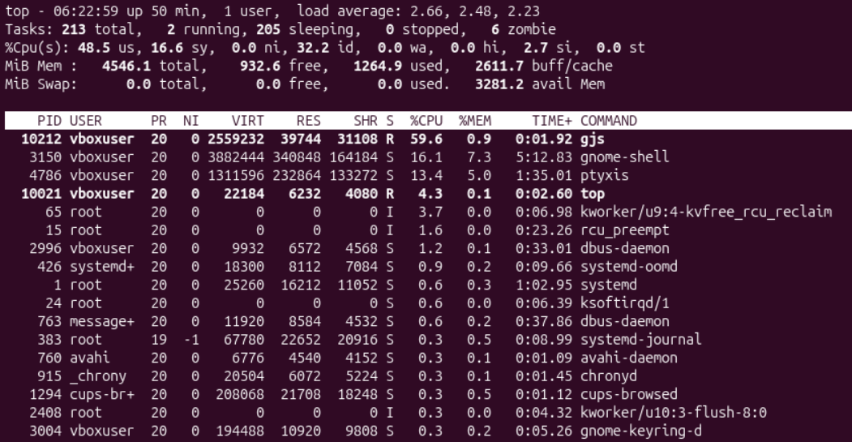
- Command : ps -ef
Description : Different services running on my virtual machine
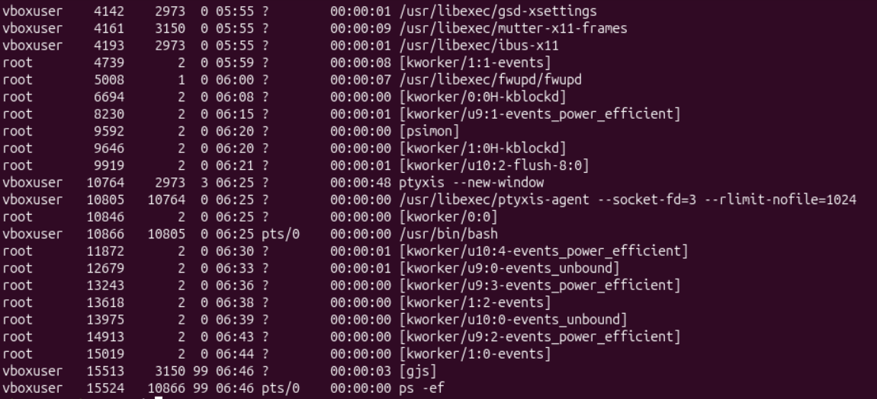
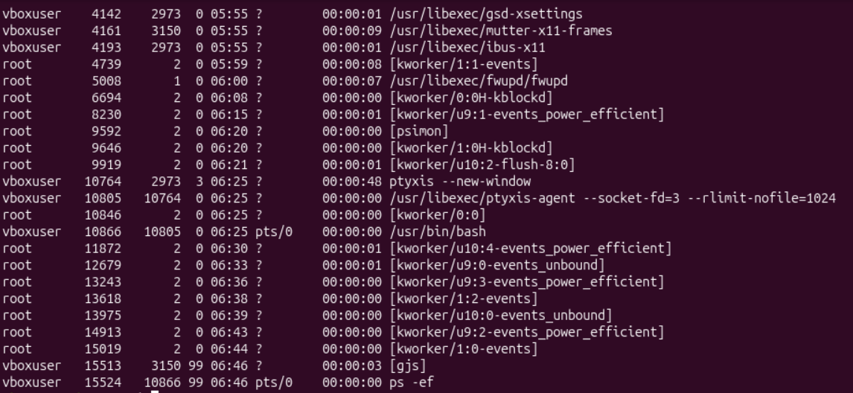
- Command : ps -ef |grep nginx
Description : grep command - to check specific key word & ps -ef is used to check list of running processes & | is called pipe
when we use pipe >> output of the 1st command =input of 2nd command(instead of long list of service, we can use this and see current service) – once if u start install, then u will get this result(below) – it will show which process is running
- Command : sudo apt install nginx
Description : nginx is the service, what i want to install in my machine, package manager for ubuntu
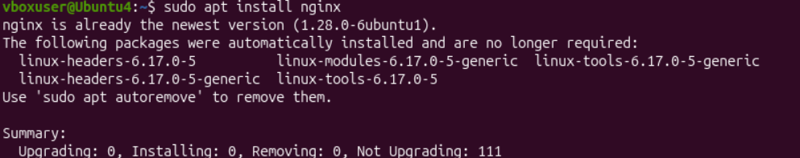
- Command : sudo systemctl status nginx
Description : to check whether it is running or not
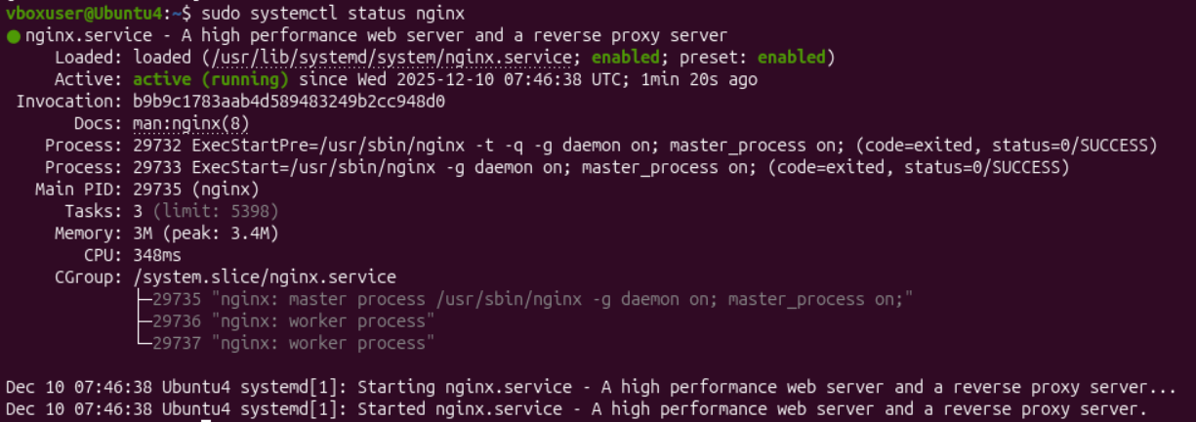
- Command : sudo systemctl start nginx
Description : it will start nginx service
- Command : id
Description : help us to know username
- Command : uname
Description : help us to know name of your machine
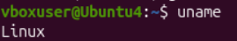
- Command : cat /etc/os-release
Description : if u want to know which OS we are in
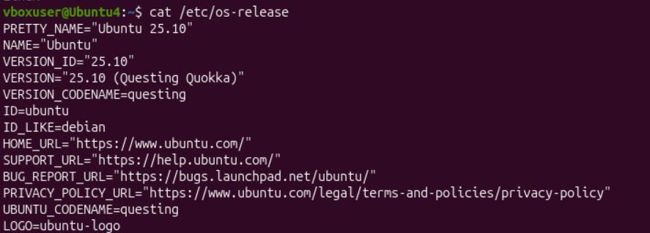
- Command : cat /proc/cpu info
Description : it will provide complete info about cpu
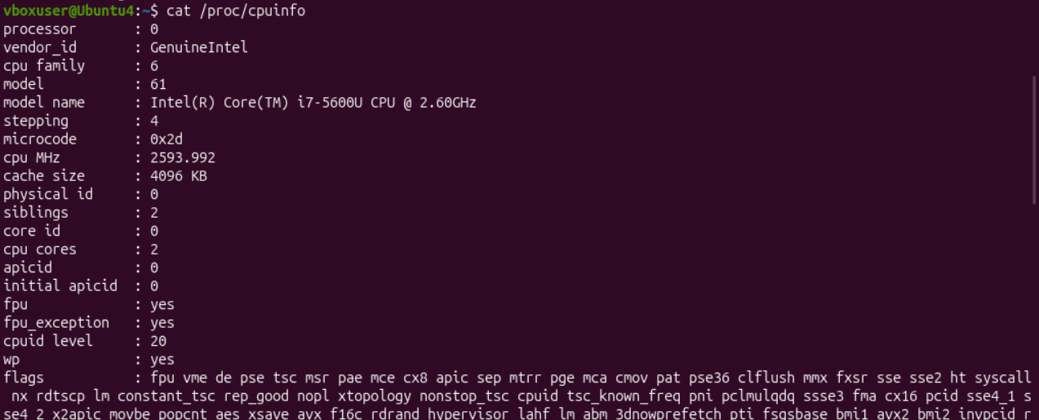
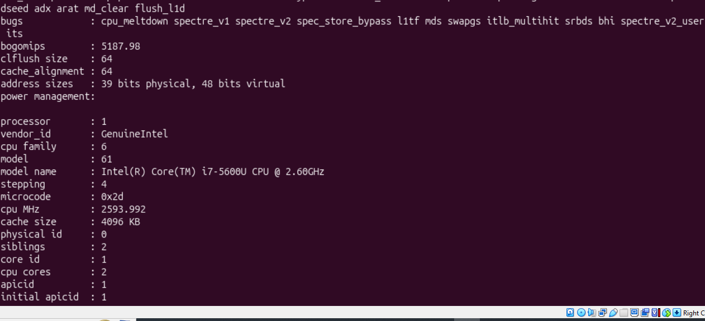11.Command : df -h
Description : To know the space of the disk
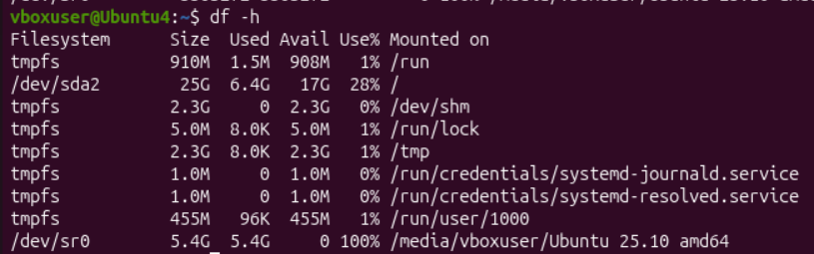
11.Command : sudo apt install apache2
Description : want to check ip address or host name of any domain.
